**Software Requirements Specification**

**for**

Bearpool

**Version 1.0**

**Prepared by Abhilash, David, Knox, Kledis, John and Tiffany**

**Team G**

**10/16/2023**

**Table of Contents**

**Table of Contents ii**

**Revision History ii**

**1. Introduction 1**

1.1 Purpose 1

1.2 Document Conventions 1

1.3 Intended Audience and Reading Suggestions 1

1.4 Project Scope 1

1.5 References 1

**2. Overall Description 2**

2.1 Product Perspective 2

2.2 Product Features 2

2.3 Assumptions and Dependencies 3

**3. System Features 3**

3.1 General features

3.2 Carpool request  
3.3 Communication during carpool request

3.4 Creating driver reviews

3.5 Other requirements 4

**4. External Interface Requirements 4**

4.1 User Interfaces 4

**5. Other Nonfunctional Requirements 5**

5.1 Performance Requirements 5

5.2 Safety Requirements 5

5.3 Security Requirements 5

5.4 Software Quality Attributes 5

**6. Other Requirements 5**

**Appendix A: Glossary 6**

**Revision History**

| **Name** | **Date** | **Reason For Changes** | **Version** |
| --- | --- | --- | --- |
| Initial document | 10/16/2023 | Created document, updated functional requirements | 1.0 |
|  |  |  |  |

# **Introduction**

## **Purpose**

Bearpool is a ride-sharing application that will connect students with each other, offering convenient transportation. in an effort to help ones without vehicles on a daily basis. The main objective of the application will be to make an effort in helping students without vehicles find transportation on a daily basis. The document will describe the software requirements needed to create such an application.

## **Document Conventions**

This Document was created based on the IEEE template for System Requirement

Specification Documents.

The following conventions in the document were used as follows:

| **Convention** | **Description** |
| --- | --- |
| Bearpool | Application name |
|  |  |

## **Intended Audience and Reading Suggestions**

This document will be made for developers, project managers, users, testers, marketing staff, and document writers.  The rest of this SRS contains Product Scope, An overall description of the product, External Interface Requirements, System Features, and Nonfunctional Requirements.

## **Project Scope**

The software will be a Web application. Specifically, the website will be built using HTML, CSS and ReactJS, i.e. mainly frontend development. It will act as a low-cost alternative to other applications, with students having the option to “spend” money when using the application’s services. This will attract more traffic towards the website.

## **References**

Bearpool GitHub Link: <https://github.com/COS420-Fall23/Team-G>

# **Overall Description**

## **Product Perspective**

Bearpool is being developed as a way of helping students who experience issues with attending classes on time due to transportation. It is also being made as a way to increase the number of available parking lots, aiming to reduce excess vehicle usage throughout campus.

## **Product Features**

Google login: Allow users to login through their Google account.  
Communicating with other users: Allows users to communicate with each other for better coordination.  
Leaving a tip: Allows riders to tip their drivers.  
Leaving review: Allows riders to rate and leave a review for their drivers.

Reporting users: Allows users to report other users in case of inconveniences.

## **Assumptions and Dependencies**

We will assume that the users will not have disabled Javascript in their browser. Otherwise, the website will not be able to function in the user’s browser.

# **System Features**

## General features

Bearpool will make it possible for every user to create an account and a profile in our application.

F_REQ_1: The system shall allow the user to log in using a student email and password.

F_REQ_2: The system shall allow the user to log in through Google.

F_REQ_3: The system shall allow the user to log out of their account.

F_REQ_4: The system shall ask the user for their home address during the creation of an account.

F_REQ_5: The system shall ask the user for their phone number during the creation of an account.

F_REQ_6: The system shall allow the user to change their home address.

F_REQ_7: The system shall allow the user to change their password.

## Carpool Request

Bearpool will allow any user to participate in a carpool request, be it as a driver or a rider. All users that will take part in the request will follow information provided by each other and displayed on the application in order for the transportation to be carried out successfully.

* F_REQ_10: The system shall allow the user to make a carpool request.
* F_REQ_15: The system shall allow users to schedule a carpool request up to 1 hour beforehand.
* F_REQ_8: The system shall allow users to edit their driving schedule, specifying the times they can provide rides to and from campus.
* F_REQ_9: The system shall allow users to change their vehicle details, including model, color, and plate number.
* F_REQ_11: The system shall provide a list of options to users requesting a ride, by order of proximity in both time and location.
* F_REQ_14: The system shall allow users to change their pick up location within 1 minute of making a carpool request.
* F_REQ_16: The system shall require both users participating in a carpool request to confirm their ride 10 minutes after the carpool request.
* F_REQ_17: The system shall allow users to cancel their carpool request at any time after initiation and before confirmation.

## Communication during carpool request

Bearpool will also provide users with a simple way of communicating with each other, in order to minimize any possible inconveniences.

* F_REQ_18: The system shall allow users to message each other during a carpool request for better coordination.
* F_REQ_19: The system shall provide drivers with a preset set of common messages, specifying the time and distance from riders.

## Creating driver review

Users that will be offered a ride while using Bearpool will have the option to rate and review their riders.

* F_REQ_20: The system shall provide users with a list of previous carpool requests.
* F_REQ_21: The system shall allow users to leave a rating and text review to a driver after the ride has finished.
  1. **Other functional requirements**
* F_REQ_12: The system shall allow users to report other users and specify a reason.
* F_REQ_13: The system shall allow users to send a tip to their driver via PayPal.

# **External Interface Requirements**

## **User Interfaces**

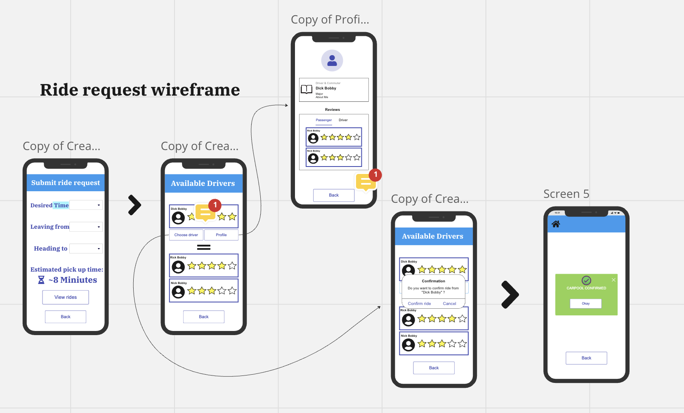

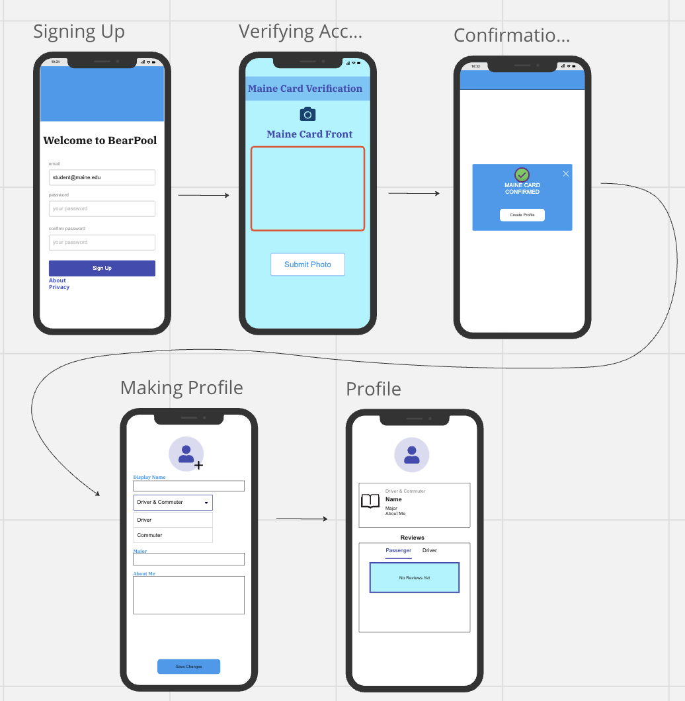

# **Other Nonfunctional Requirements**

## **Performance Requirements**

*Availability: The Bearpool application should be available 24/7, ensuring students can request rides at any time of the day with an allowed down time of 2 hours per month.*

*Response Time: The app should provide ride matches within a maximum of 10 seconds, 95% of the time.*

*Notification Speed: Users should be notified of their ride status (e.g., match found, ride arrival) within 5 seconds.*

*Matching Accuracy: The system should have at least an 80% success rate in matching students with similar schedules.*

## **Safety Requirements**

*Driver Verification: All drivers should undergo a thorough verification process to ensure passengers' safety.*

*Route Logging: Every trip's route should be logged and retrievable for a specified duration, aiding in any safety investigations if required.*

## **Security Requirements**

*Data Encryption: Personal data, especially locations and contact details, should be encrypted.*

*Authentication: Employ multi-factor authentication for user logins to prevent unauthorized access.*

*Privacy Adherence: Ensure compliance with GDPR, CCPA given the personal nature of ride-sharing data.*

*Payment Security: Implement secure payment gateways and ensure no sensitive payment data is stored on the app's servers.*

## **Software Quality Attributes**

*Reliability: Aim for 99.9% uptime, especially during peak class hours, ensuring consistent service.*

*Usability: An intuitive UI/UX is crucial. At least 90% of new users should be able to schedule a ride without needing guidance.*

*Portability: The app should run smoothly on both Android and iOS platforms.*

# **Other Requirements**

*Environmental Impact: Encourage carpooling not just for convenience but as an eco-friendly solution.*

*Legal Adherence: Adhere to the Maine Transportation Network Company Safety and Regulatory Compliance standards.*

**Appendix A: Glossary**

*<Define all the terms necessary to properly interpret the SRS, including acronyms and abbreviations. You may wish to build a separate glossary that spans multiple projects or the entire organization, and just include terms specific to a single project in each SRS.>*